**Literature Review**

Today, there are a number of websites that are affiliated with eCommerce, offering their services on products and services. Each of these sites features unique features, functionality, and unique features. Websites like Alibaba.com, Ikman.lk, Patpat.lk can be identified as the most popular websites that we can identify.

If you take the ikman.lk website, the various products and services on the site are designed in such a way that users can access and use those categories in separate categories using different categories. A unique feature of the site is that visitors are able to find the product they want using the search bar. The price, images, details of the product, etc. that should be mentioned in relation to any such advertisement are also clearly stated in this website. These websites also allow customers to connect directly with the person who advertised the service. In other words, all of these sites have the same unique characteristics. When posting ads on these websites, you can easily enter the details of the relevant ad and post it. But on some websites, you have to pay a certain amount to post an advertisement.

And all of these websites use databases to keep users' data and ad data secure.

Another factor that can be found on these sites is that anyone who visits the site can also search for details about items currently for sale around his or her area. The company also offers the convenience of home delivery of the products they currently have for sale on their website when a customer needs them. Various such technologies have been used in these sites.

We used ikman.lk, patpat.lk and alibaba.com to develop our website. All these websites provide facility to buy goods and sell goods online. The main reason we used these websites for the development of our website was because they made it possible to use the website very easily.

* **Home Page designing**

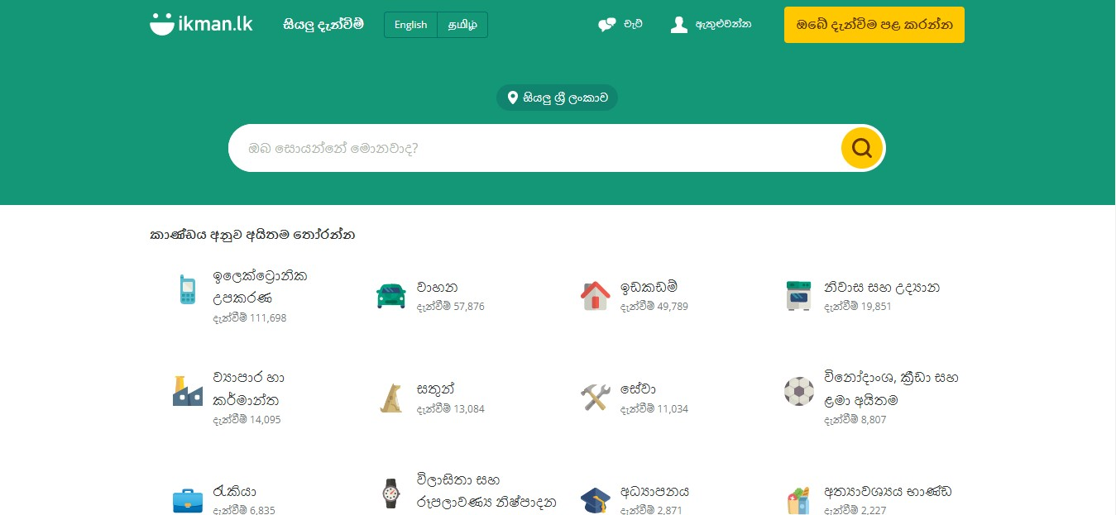

This is how we designed our home page. There we made some changes and we hoped to create our own creation. It was designed in such a way that the subcategories of the product category on our website are shown on the side. We assumed that it would be easier for the users who come to the website to use the website. Also, as shown in the above diagram, a search bar was also added to our website. It makes it easy for users to find any item.

* **Register Page.**

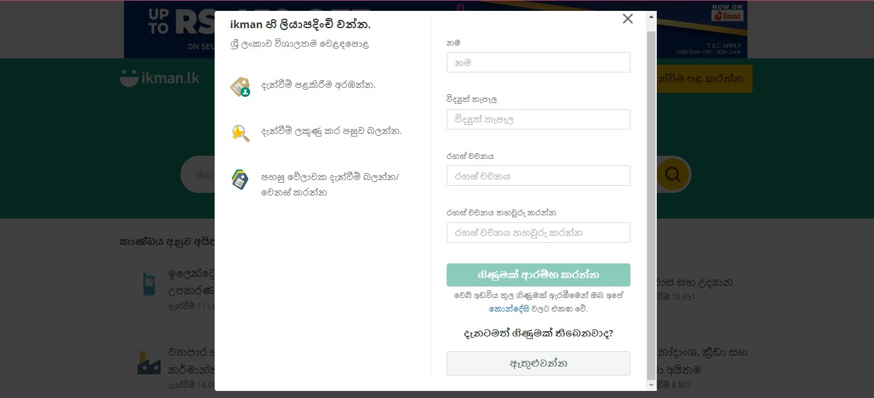

This is how we set up our registration page. There we added some validations so that no text field can be left blank. Accordingly, the changes we have made here are that only digits should be used for entering the phone number and it was made so that no more than 10 digits can be entered. And the email address should be entered according to the regular method.

* **Login Page.**

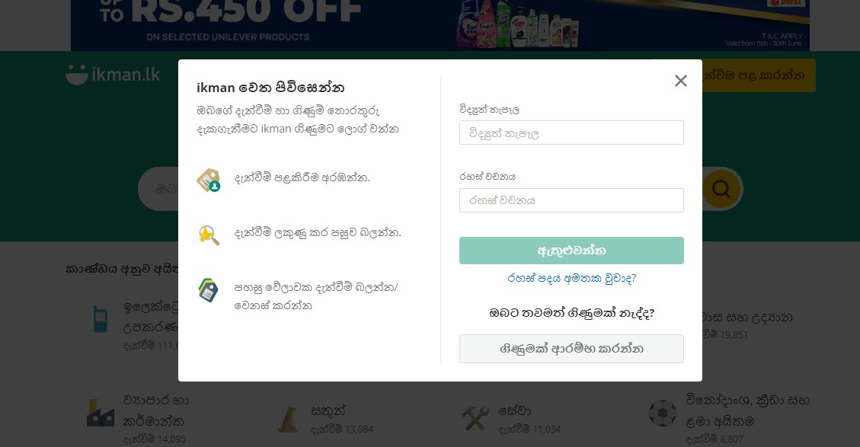

Our login page has been modified and created anew using this and here, just like the login menu in the diagram, the login menu of our website also provided the necessary facility to log into the website after entering the email address and password. This page is being created and empty fields validation has been included for all these text fields.